Fuel Level Gauge – CGEA 1.3 P558 Dual Tank Supplement

Functional Description

This is a supplement that is to be used with Fuel Level Gauge – CGEA 1.3 to specify the functional requirements for the additional HMI that is used for dual tanks.

As background, Super Duty offers an option to have 2 fuel tanks, each with a separate filler tube. The previous Super Duty programs (P473, P356, P131) had a switch on the I/P to select “Tank A/ Tank B” or “Front Tank/ Rear Tank”. This switch does not exist on P558. Effectively, the fuel system on this vehicle will work like a saddle tank, but will have 2 filler tubes instead of 1. Note that the 2 filler tubes are always on the left (driver side) of the vehicle.

Also, the fuel system will have the limitation that if both tanks are run dry, and the user only refills the secondary tank, that the vehicle may not restart. The customer has to re-fill the primary tank first if you run out on both. Note that with the
jet pump operation, the secondary tank would always run to empty first, then the primary tank.

A dual tank P558 SuperDuty will be DExx configured as a saddle tank (“# of Fuel Senders” = 2 Senders and “# of Fuel Tanks” = 1 Tank). Setting the parameter “# of Fuel Tanks” = 2 Tanks is intended for older SuperDuty’s where there is NOT a jet pump between the 2 tanks.

The wiring agreement is that the Primary (front) tank is tank #1, and that the Auxiliary Tank (rear) is tank #2.

The HMI for a dual tank on P558 is as follows. There is a combined fuel level gauge that shows the weighted average of both tanks, along with the DTE value that is based on both tanks. (This is the same as any other vehicle, and is described in the Fuel Level Gauge STSS).

Additionally, there is a separate display for each individual tank. The individual tank levels are shown on a single screen on an L1 and L2 cluster. They are shown on 2 screens on an L0 cluster. (These individual tank displays are the subject of this supplement).

Starting with the MY20 P558 MCA program, the vehicle is using PCM algorithm based fuel level gauge. Thus, to display the individual fuel tank levels, 2 new CAN signals were defined.

Interfaces

Interface Context Diagram (I/O Block Diagram)

Inputs

- INTERNAL:
• HW input for TANK_SELECT (HW) signal – Not Applicable to P558.

- MUX signals

- FuelLvlAct_Pc_DsplyEng (CAN) Signal (PCM Algorithm Only)
Signal Name | Size  (bits) | Detail | Units | Res. | Offset | State Encoded | Min. | Max.
FuelLvlAct_Pc_DsplyEng | 10 |  | % Indication | 0.108696 | -5.217408 |  | -5.217408 (0x0) | 105.9786 (0x3FF)

- FuelLvlPss_Pc_DsplyEng (CAN) Signal (PCM Algorithm Only)
Signal Name | Size  (bits) | Detail | Units | Res. | Offset | State Encoded | Min. | Max.
FuelLvlPss_Pc_DsplyEng | 10 |  | % Indication | 0.108696 | -5.217408 |  | -5.217408 (0x0) | 105.9786 (0x3FF)

Outputs

Function/Performance

Operational Modes

Mode | Differentiating Vehicle Conditions
Sleep Mode | Fuel Level Gauge needle at “Rest” position
Limiting Mode | Fuel Level Gauge needle at “Rest”position
Normal Mode | Fuel Level Gauge needle at “Fuel Level Gauge Indication”  Fuel Level A/D and sensor output status available
Crank Mode | Fuel Level Gauge needle at “Fuel Level Gauge Indication” or last “Fuel Level Gauge Indication” determined in Normal Mode.

Voltage Levels
Refer to the Cluster Features table located in the Operational Modes and Voltage Range Strategy Section in this SPSS.

Human-Machine Interface

Visual

Indicator Graphics / Display Format

For graphics, refer to approved studio data. Below are examples.

L0:
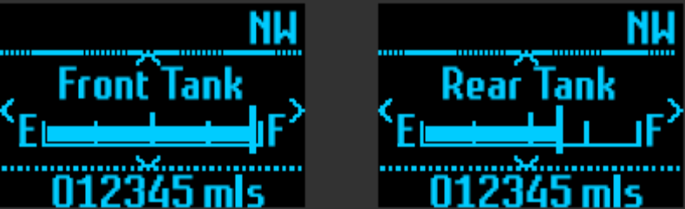

L1:
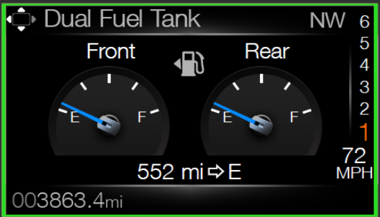

L2:
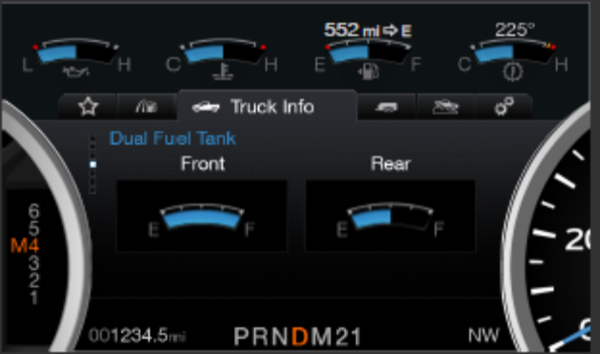

Indicator Color Coordinates
Refer to approved Studio data.

Indicator Characteristics
Refer to approved studio data.

Audio
None.

System Accuracy
Refer to Fuel Level Gauge STSS.

Operation: Performance and Functional

Subsystem Algorithm Flowchart / State Diagram
Refer to Fuel Level Gauge STSS.

Refer to Fuel Level Gauge STSS for the remainder of this Table.

Table 1.10 Descriptions of Fuel Level Parameters

Parameter Name | Description | Value at Battery connect | Value at  Module Wake-up
FuelLvlAct_Pc_DsplyEng | CAN Input signal for Fuel Level for Front fuel tank (Tank 1) when PCM performs Fuel Level Algorithm | 0 | Do Not Init
FuelLvlPss_Pc_DsplyEng | CAN Input signal for Fuel Level for Rear fuel tank (Tank 2) when PCM performs Fuel Level Algorithm | 0 | Do Not Init

Operation Description (supports algorithm flowchart /state diagram)

- Shall display Dual Fuel Tank graphics when "# of Fuel Senders" = 2 Senders.

- When FuelLvl_PCM_Cfg = 0x0 (IPC)
  - Shall use F_L_P_M[1] to drive front tank graphics
  - Shall use F_L_P_M[2] to drive rear tank graphics

- When FuelLvl_PCM_Cfg = 0x1 (PCM)
  - Shall use FuelLvlAct_Pc_DsplyEng to drive front tank graphics
  - Shall use FuelLvlPss_Pc_DsplyEng to drive rear tank graphics

Function Safety Classification (EMC)

Class B

Memory Storage

Refer to Fuel Level Gauge STSS for the remainder of this Table.

Table 1.13 Default Fuel Constants*

Fuel Constant Name | Description | Default Value | Units
FDM Weighting Factor | The weighting factor applied to the Sender(1) data (FDM side of a dual sender single tank system) when determining total fuel level.  Value needs to be determined by Fuel System Engineer. | 39.8% of total tank for dual sender single tank systems  100% for single sender systems | %
PFM Weighting Factor | The weighting factor applied to the Sender(2) data (PFM side of a dual sender single tank system) when determining total fuel level.  Value needs to be determined by Fuel System Engineer. | 60.2% of total tank for dual sender single tank systems  0% for single sender systems | %

Prove Out

No

Reconfigurable Telltale

No

Message Center Msg

No

Error Handling

Missing Message Strategy

The signals will be declared missing as per the Diagnostics Section of this SPSS.

DTCs states and history will be determined as per the Diagnostics Section of this SPSS.

Invalid Message Strategy

The signals will be declared invalid as per the Diagnostics Section of this SPSS.

DTCs states and history will be determined as per the Diagnostics Section of this SPSS.

Diagnostics

Self Test
None

Engineering Test Mode
Refer to Fuel Level Gauge STSS.

Part II Performance
Refer to Fuel Level Gauge STSS.

Note to P558 cluster D&R and Netcom Engineer for VSCS:
A dual tank P558 SuperDuty will be DExx configured as a saddle tank
(“# of Fuel Senders” = 2 Senders and “# of Fuel Tanks” = 1 Tank).

Reference Specification

Revision History

SPSS Module Revision History
Revision Level | Name | Change Description | Date
1.0 | S. Watkins | Initial Release | 6/3/2014
1.1 | A. Venuturupalli  S. Watkins | Section 1.3.5.4, Table 1.13 – Changed the FDM/PFM Weighting factors to 39.8%/60.2% (confirmed values with Guido Barta and Chris Lilly on 06/02/2015).  Front 26.5 gal (39.8%)  Rear 40 gal (60.2%)  Per Denso Q&A P558 MY17 #715 | 6/9/2015
2.0 | S. Watkins | Starting with the MY20 P558 MCA program, the vehicle is using PCM algorithm based fuel level gauge. Thus, to display the individual fuel tank levels, 2 new CAN signals were defined.  FuelLvlAct_Pc_DsplyEng, FuelLvlPss_Pc_DsplyEng  Changes highlighted in green.  - Section 1.1 – Updated description  - Section 1.2.2 – Added 2 new CAN signals  - Section 1.3.5.1 – Added 2 new CAN signals  - Section 1.3.5.2 – Added requirements for how to display graphics using the new CAN signals. | 9/16/2018

